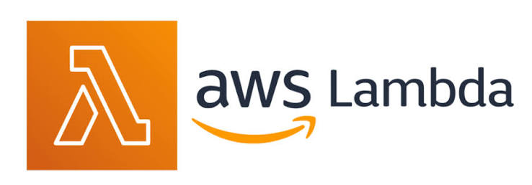

AWS Lambda –
AWS Lambda is a serverless compute service that runs your code automatically when an event occurs, without you having to create or manage servers and It lets you run your code only when it is needed. AWS takes care of servers for you
- No server management
- Automatic scaling
- Pay only for execution time
- Supports multiple programming languages

What Does “Serverless” Mean ?
Serverless doesn’t mean no servers, it means you don’t manage servers. AWS automatically handles the following –
- No need to worry about server setup.
- Resources scale as per demand
- AWS takes care of upkeep.
- Developers can focus solely on writing code.

How AWS Lambda Works --
Write Code
│
Upload to Lambda
│
Configure Trigger
│
Event Occurs
│
Lambda Executes Code
│
Returns Response
│
Stops Automatically

Here Aws manages Infrastructure, Scaling, Patching, Availability

Features of AWS Lambda –
- Serverless architecture
- Automatic scaling
- High availability
- Built-in monitoring with CloudWatch
- Supports Python, Java, Node.js, .NET, Go, Ruby, and custom runtimes
- Easy integration with AWS services like S3, DynamoDB, and API Gateway
Types of Lambda invocations –
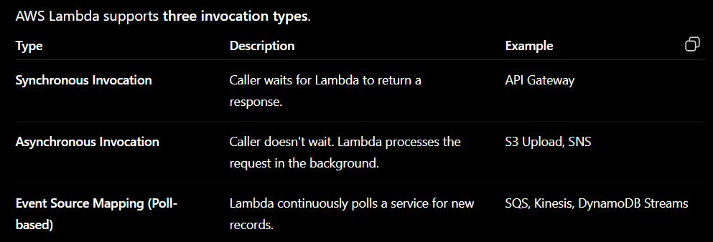

1. Synchronous Invocation
Characteristics
- Immediate response - Lambda processes the request immediately and sends the result back to the client.
- Client waits - The client (browser, mobile app, or API) waits until Lambda completes its work
- Used for REST APIs - REST APIs need an immediate response because the client is expecting data.
2. Asynchronous Invocation
- No waiting for response
- AWS retries automatically if Lambda fails
- Suitable for background tasks
3. Event Source Mapping
- Processes batches of records
- Used for large-scale event processing

AWS Services That Can Trigger Lambda –

AWS Lambda can be triggered by various AWS services whenever a specific event occurs. These services automatically invoke the Lambda function to perform a task.
1. API Gateway –
An HTTP/HTTPS API request from a client.
2. Amazon S3 –
Uploading, deleting, or modifying an object in an S3 bucket.
3. Amazon DynamoDB Streams –
Whenever data is inserted, updated, or deleted in a DynamoDB table.
4. Amazon SQS (Simple Queue Service) –
New messages arriving in an SQS queue.
5. Amazon SNS (Simple Notification Service) –
A message published to an SNS topic.
6. Amazon EventBridge (CloudWatch Events) –
A scheduled event or an AWS service event
7. Application Load Balancer (ALB)
An HTTP or HTTPS request received by the ALB.
8. CloudFront –
A user request reaching CloudFront (using Lambda@Edge).

Advantages of Lambda –
No infrastructure management –
AWS manages the servers, operating system, and maintenance, so you only focus on writing code.

Automatic scaling –
Lambda automatically increases or decreases the number of function executions based on incoming requests.

Cost-effective (Pay per use) –
You are charged only for the number of requests and the time your code runs.

High availability –
Lambda automatically runs across multiple Availability Zones to provide high availability and fault tolerance

Quick deployment –
You can deploy your code in minutes without setting up or configuring servers.

Supports event-driven architectures –
Lambda automatically executes your code whenever a configured event or trigger occurs.

Limitations of AWS Lambda –
Maximum execution time: 15 minutes –
A Lambda function can run for a maximum of 15 minutes, after which AWS automatically stops it.

Memory limit: Up to 10 GB –
A Lambda function can be configured with a maximum of 10 GB of memory, depending on the application's requirements

Not suitable for long-running applications –
Lambda is not ideal for applications that require continuous or long-running processing beyond 15 minutes.

